Health Profession Agreement

Psychology Board of Australia

and

The Australian Health Practitioner Regulation Agency

2016-20

Health Profession Agreement
Preamble
The purpose of the Health Practitioner Regulation National Law (the National Law), as in force in each state and territory, is to establish the National Registration and Accreditation Scheme (the National Scheme). The National Scheme has six key objectives set out in s.3(2) of the National Law. In summary, the objectives are to:
  - protect public safety,
  - facilitate workforce mobility for health practitioners,
  - facilitate high-quality education and training of health practitioners,
  - facilitate assessment of overseas-trained health practitioners,
  - facilitate access to health services, and
- development of a flexible, responsive and sustainable health workforce.
Fourteen National Boards and the Australian Health Practitioner Regulation Agency (AHPRA) work in partnership to achieve these objectives, with different and complementary functions.
The HPA is a statutory instrument. The National Board and AHPRA are required to negotiate in good faith and attempt to come to an agreement on the terms of the HPA. Although the National Board does not have the power to enter into contracts generally (as provided for in s.32(2)(a)), the National Law clearly intends that the National Board can agree and enter into an HPA with AHPRA. Furthermore, the National Board and AHPRA are each a separate body corporate, capable of reaching agreements between themselves.
The following schedules to this HPA record AHPRA and the National Board’s agreement on these matters: fees (Schedule 3); the National Board’s annual budget (Schedule 4); and the services AHPRA is to provide (Schedule 1).
The National Law also requires each National Board to publish on its website the fees agreed to in this HPA.
Accountabilities
Ministerial Council
Ultimate accountability to the public for the performance of the National Scheme rests with the parliaments of participating jurisdictions, through the Australian Health Workforce Ministerial Council (the Ministerial Council). The Ministerial Council appoints AHPRA’s Agency Management Committee and National Boards, and formally holds these bodies to account.
National Boards
A National Board is a body corporate with perpetual succession, has a common seal, and may sue and be sued in its corporate name. A National Board does not have power to enter into contracts, or employ staff, or acquire, hold, dispose of, and deal with, real property.
The principal regulatory decision-makers in the National Scheme are the National Boards and their committees, including, where relevant, State and Territory or Regional Boards. AHPRA undertakes delegated functions on behalf of the National Boards and provides services to the National Boards. National Boards are accountable to the community through the mechanism of the Ministerial Council and parliamentary reporting for the quality of their regulatory decisions, and through the court system and relevant administrative review bodies for the legality of their regulatory decisions. While National Boards can propose regulatory procedures, they do not establish or administer them. National Boards have specific ‘oversight’ roles in relation to the assessment of overseas qualifications, monitoring of practitioners and the receipt, assessment and investigation of notifications. Without the power to employ staff or enter into contracts, National Boards must rely on the services provided, or contracted, by AHPRA. The mechanism for National Boards to hold AHPRA to account is through this Health Profession Agreement. The Health Profession Agreement includes performance indicators to support the performance of National Boards’ oversight functions.
AHPRA
AHPRA is a body corporate with perpetual succession, has a common seal, and may sue and be sued in its corporate name. AHPRA has all the powers of an individual and in particular, may enter into contracts, or employ staff, or acquire, hold, dispose of, and deal with, real and personal property, and do anything necessary or convenient to be done in the exercise of its functions.
AHPRA’s Agency Management Committee directs and controls the affairs of AHPRA, and sets its policy directions. The Agency Management Committee is accountable for the performance of AHPRA’s functions, which include the establishment of regulatory procedures, financial management and administration of the Scheme. AHPRA is solely responsible for administering the Agency Fund, which has an account for each National Board. Payments out of a National Board’s account may be made only if the payment is in accordance with the National Board’s budget, as agreed as part of this Health Profession Agreement, or otherwise approved by the National Board. To enable it to perform the executive functions within the Scheme, AHPRA has powers to employ staff and enter into contracts. AHPRA provides administrative assistance and support to National Boards and their committees to exercise their functions.
AHPRA and the National Board can be described as governance partners in the Scheme. This is largely because AHPRA relies on National Boards to perform their functions consistent with the National Law objectives and in line with procedures established by AHPRA for ensuring effective and efficient operation of National Boards and to comply with procedures for development of professional standards that are in accordance with good regulatory practice.
The Agency Management Committee is accountable for ensuring that the corporate functions that are essential to any contemporary regulatory organisation are in place. This means that corporate services, including human resources, business planning, financial management and facilities management, are generally not specified in the services AHPRA is to provide (Schedule 1) except where the service deliverable is provided directly to the National Boards.
Purpose of this Agreement
The purpose of a Health Profession Agreement (HPA) is described in s.26(1) of the National Law, which provides that AHPRA must enter into a HPA with a National Board that makes provision for:
  - fees payable by health practitioners and others in relation to the health profession for which the National Board is established,
  - the National Board’s annual budget,
- the services to be provided to the National Board by AHPRA to enable the National Board to carry out its functions.
This HPA outlines agreement between the National Board and AHPRA on their general approach to performing their reciprocal obligations to ensure a common understanding and that the National Scheme operates with regard to its objectives and guiding principles.
Scope of this Agreement
This Agreement is for the period 1 July 2016 to 30 June 2020.
The National Board agrees to authorise the Chair of the Board (or his/her nominee) to act as liaison officer with respect to the Agreement. AHPRA agrees to authorise the Executive Director, Strategy and Policy to act as liaison officer with respect to the Agreement.

Partnership principles
To achieve the objectives of the National Law through different and complementary functions, the National Board and AHPRA understand that a sustainable partnership is essential.
This understanding is supported by a set of core partnership principles (the Partnership Principles). The National Board and AHPRA will ensure that these Partnership Principles underpin all our work. While differences in context may require different approaches, both parties will ensure that their respective activities respect these four Partnership Principles:
  - Shared vision and values
  - Integrity through interdependence
  - Transparency and mutual accountability
  - Commitment to joint learning
In particular, the National Board will do everything it can to make its requirements clear, and AHPRA will do everything it can to provide the services required by the National Board to perform its functions.
Each of the Partnership Principles is described in detail below.
1. Shared vision and values
This partnership between the National Board and AHPRA is built on a shared vision for a competent and flexible health workforce that meets the needs of the Australian community.
While recognising and respecting the different and complementary functions of the National Board and AHPRA, there must be common ground in the approach the National Board and AHPRA take to implementing the National Scheme. The National Board and AHPRA share a commitment to the objectives and guiding principles of the National Scheme and the eight regulatory principles (Regulatory Principles) that will shape our thinking about regulatory decision-making.
In our shared principles, we balance all the objectives of the National Scheme, but our primary consideration is to protect the public in accordance with good regulatory practice.

The Regulatory Principles incorporate the concept of risk-based regulation. This means that in all areas of our work we:
- identify the risks that we are obliged to respond to,
  - assess the likelihood and possible consequences of the risks, and
  - respond in ways that are proportionate and manage risks so we can adequately protect the public.
In recognising our different and complementary functions, the National Board and AHPRA have agreed on an accountability framework for the National Scheme (the Accountability Framework).
The Accountability Framework recognises that all entities in the National Scheme are ultimately accountable to the Australian public through the Australian Health Workforce Ministerial Council (the Ministerial Council).
One of the recognised features of the National Scheme is that our structure provides for governance and accountability across the entities in the National Scheme for their performance. The effective delivery of professional regulation relies on strong partnerships between entities based on clear and agreed roles and functions. Our Accountability Framework is designed to articulate a shared understanding regarding who is accountable for what within the National Scheme and aims to provide clarity about the distinct and complementary roles of the different entities, and their respective duties and obligations.

2. Integrity through interdependence
In exercising our different and complementary functions, the National Board and AHPRA will strive for mutual respect and to promote the integrity of the National Scheme. We are aware we have interdependent and complementary functions. The National Board and AHPRA will work to manage any tensions that arise through our consultation processes and the Accountability Framework.
We will each take responsibility for clearly communicating our positions to each other. We are each open to being challenged by the other, and we will each create opportunities for dialogue and debate around our respective approach, results and impact. While the National Board and AHPRA are each independent entities, we recognise that neither can meaningfully exist outside of the context of the relationship defined by the National Law. We agree to respect the other’s functions as set out in the National Law.
For example, AHPRA acknowledges its obligation to consult the National Board when developing procedures for the operation of the National Board, and will endeavour to incorporate the National Board’s feedback into those procedures. The National Board respects that AHPRA must endeavour to establish common procedures that apply to all National Boards and undertakes to comply with those procedures once finalised.
The National Board and AHPRA also have complementary duties in relation to financial management. AHPRA is accountable for the management of the Agency Fund and for ensuring that all expenditure from the National Board’s account is consistent with the National Law, in accordance with the Board’s annual budget (or with the approval of the National Board if a change to the agreed budget), and as far as possible represents reasonable value for money. Accountability for expenditure rests with the AHPRA financial delegate who approves that expenditure, including payments to enable the National Board to exercise its functions. The National Board respects this role and undertakes to support AHPRA in fulfilling this role and its obligations under the National Law generally.
3. Transparency and mutual accountability
The Health Profession Agreement is the formal mechanism by which we hold each other to account, in accordance with the National Law and the Accountability Framework. It incorporates a transparent reporting framework to ensure that reciprocal obligations can be monitored.
The Agency Management Committee is formally accountable for AHPRA’s performance of its functions. The National Board relies on AHPRA to deliver services to it in order for it to carry out its functions. In turn AHPRA relies on National Boards to perform their functions consistent with the National Law objectives and in line with procedures established by AHPRA for ensuring effective and efficient operation of National Boards and procedures for development of professional standards that are in accordance with good regulatory practice.
Schedule 1 to this HPA outlines the services to be provided to the National Board by AHPRA to enable the National Board to carry out its functions. It also includes information about AHPRA’s performance of its own statutory functions. Schedule 1 also includes profession-specific services and any discretionary services the National Board may request of AHPRA.
In addition, the Agreement supports the National Board to fulfil its specific oversight functions in respect of:
  - the assessment of overseas trained registration applicants who do not hold approved qualifications
  - the assessment and investigation of matters about persons who—
    - are or were registered health practitioners, or
    - are students in the health profession,
  - the management of registered health practitioners and students in the health profession, including monitoring conditions, undertaking and suspensions imposed on the registration of the practitioners or students.
In order to exercise these functions, the National Board must be given the opportunity to review timely information regarding relevant activities undertaken by AHPRA and the National Boards’ delegates, to raise questions and concerns and to suggest actions to remediate problems. AHPRA undertakes to ensure that performance reports will be provided to the National Board to fulfil these oversight functions; in particular these reports will include details of the timeliness, cost and quality of regulatory procedures and services AHPRA provides to the National Board. The performance reports AHPRA will provide, and the performance indicators underpinning them, are set out in Schedule 5 to this HPA.
4. Commitment to joint learning
The National Board and AHPRA agree to promote continuous and systematic learning regarding the National Scheme. We will evaluate the outcomes of business and regulatory processes and use data generated by the National Scheme to better understand the risks we manage and the effectiveness of our actions.
Our learning agenda will explore both partnership processes and outcomes. We will take an evaluative approach to regulation that uses data to identify risks and measure our effectiveness in managing them. The National Board and AHPRA both have an interest in understanding the factors, including ways of working, which are the hallmarks of successful partnerships. We will work together to ensure that joint learning is used regularly to adjust our future strategy and plans as we strive for increased efficiency and effectiveness of the National Scheme.
The National Board and AHPRA are committed to the efficient management and continuous improvement of their respective functions.
Dispute resolution
The National Law provides that any failure to reach agreement between National Boards and AHPRA on matters relating the HPA is to be referred to the Ministerial Council for resolution.
The National Board and AHPRA have a commitment to resolve problems or disputes promptly. However, if a dispute arises regarding this HPA, as partners we will use our best endeavours to resolve the dispute fairly and promptly.
If the dispute cannot be resolved, the matter will be referred to the AHPRA Chief Executive Officer and the Chair of the National Board. If the dispute still cannot be resolved, it will be referred to the Chair of AHPRA’s Agency Management Committee and the Chair of the National Board.
Either the Chair of AHPRA’s Agency Management Committee or the Chair of the National Board may request the appointment of an independent, accredited mediator at any stage in the process.
If we are still unable to agree on the matter, we will seek direction from the Ministerial Council about how the dispute to be resolved.
Review

The National Board and AHPRA agree to review this HPA on an annual basis.

Schedules
Schedule 1: | Summary of Services to be provided to the National Board by AHPRA to enable the National Board to carry out its functions
Schedule 2: | Summary of National Scheme Strategy, implementation map, and National Board’s regulatory plan
Schedule 3: | Fees payable by health practitioners
Schedule 4: | Summary of National Board’s annual budget
Schedule 5: | Performance management framework

This Agreement is made between
Psychology Board of Australia
and
The Australian Health Practitioner Regulation Agency (AHPRA)
Signed for and on behalf of AHPRA by:  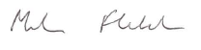 | Signed for and on behalf of the Psychology Board of Australia by:  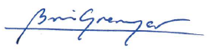
Signature of Chief Executive Officer | Signature of the Board Chair
Mr Martin Fletcher | Professor Brin Grenyer
Date | Date 08 September 2016

Schedule 1: Summary of services to be provided to the National Board by AHPRA to enable the National Board to carry out its functions

Regulatory services, procedures and processes

1.1 Registrations
Core | Profession Specific
1.1.1 Develop, implement and regularly review nationally consistent procedures for the registration of health practitioners | Profession-specific services, as listed in the National Board’s regulatory plan and annual budget.
1.1.2 Manage practitioner registration, renewal and audit
1.1.3 Maintain a public register of health practitioners
1.1.4 Maintain a register of health practitioner students
1.1.5 Promote online registration services to health practitioners
1.1.6 Operation of examinations (if required) is agreed between AHPRA and the National Board

1.2 Notifications
Core | Profession Specific
1.2.1 Develop, implement and regularly review nationally consistent procedures to receive and deal with notifications against persons who are or were registered health practitioners and students | Profession-specific services, as listed in the National Board’s regulatory plan and annual budget.
1.2.2 Manage the end to end notification process
1.2.3 Establish and maintain relationships with co-regulatory authorities.

1.3 Compliance
Core | Profession Specific
1.3.1 Develop compliance policy, process and systems | Profession-specific services, as listed in the National Board’s regulatory plan and annual budget.
1.3.2 Manage practitioners with registration restrictions, suspension or cancellation
1.3.3 Oversee the ongoing development and reporting of performance measures for monitoring of practitioners compliance

1.4 Legal Services
Core | Profession Specific
1.4.1 Provide legal advice to support effective and lawful registration and notifications procedures, and hearing panels processes | Profession-specific services, as listed in the National Board’s regulatory plan and annual budget.
1.4.2 Provide oversight for all Tribunal matters involving AHPRA and the National Boards

- Governance and Secretariat

2.1 Governance
Core | Profession Specific
2.1.1 Develop and administer procedures to support effective and efficient National Board and committee operations | Profession-specific services, as listed in the National Board’s regulatory plan and annual budget.
2.1.2 Provide National Board member orientation, induction and professional development
2.1.3 Support working relationships with relevant committees

2.2 Secretariat
Core | Profession Specific
2.2.1 Provide secretariat and administrative support for National Board Meetings | Profession-specific services, as listed in the National Board’s regulatory plan and annual budget.
2.2.2 Provide secretariat and administrative support for National Board committee meetings
2.2.3 Provide panel hearing secretariat support
2.2.4 Secretariat and policy support for governance forums, including the Forum of Chairs and its sub-committees

- Communication and Engagement

3.1 Communication
Core | Profession Specific

3.1.1 Develop, implement and review communication strategies, tools and guidelines | Profession-specific services, as listed in the National Board’s regulatory plan and annual budget.
3.1.2 Develop and release National Board communiqués
3.1.3 Review and release National Board media releases
3.1.4 Develop and maintain National Board website and resources
3.1.5 Coordinate and manage the production of the AHPRA annual report and other publications
3.1.6 Provide communications support for crisis and issue management
3.1.7 Develop and produce National Board newsletters and news updates
3.1.8 Develop Branding for National Board and AHPRA Communication
3.1.9 Report on relevant media coverage
3.1.10 Manage social media

3.2 Engagement
Core | Profession Specific
3.2.1 Engage with external stakeholders | Profession-specific services, as listed in the National Board’s regulatory plan and annual budget.
3.2.2 Manage intergovernmental relations
3.2.3 Undertake consultation to support cross-profession strategies and guidelines
3.2.4 Engage with external advisory groups
3.2.5 Monitor stakeholder engagement activities

- Planning and Reporting

4.1 Planning
Core | Profession Specific
4.1.1 Inform and support the NRAS Strategy | Profession-specific services, as listed in the National Board’s regulatory
4.1.2 Develop and implement AHPRA Business Plan

4.1.3
Develop and implement National Board Regulatory Plan
plan and annual budget.
4.1.4 HPA engagement and development

4.2 Reporting
Core | Profession Specific
4.2.1 Develop and report on outcomes related to National Boards’ regulatory functions and AHPRA’s administrative assistance and support to National Boards and the Boards’ committees, in exercising their functions. | Profession-specific services, as listed in the National Board’s regulatory plan and annual budget.
4.2.2 Establish corporate audit and compliance monitoring and reporting
4.2.3 Fulfil annual reporting requirements

- Policy and Accreditation

5.1 Policy
Core | Profession Specific
5.1.1 Maintain procedures for the development of registration standards, codes and guidelines | Profession-specific services, as listed in the National Board’s regulatory plan and annual budget.
5.1.2 Develop, review and implement cross-profession standards, codes and guidelines
5.1.3 Assist National Boards to develop, review and implement cross- profession regulatory policy
5.1.4 Provides tools to support regulatory policy development, review and evaluation

5.2 Accreditation
Core | Profession Specific
5.2.1 Support National Boards to oversight effective delivery of accreditation functions | Profession-specific services, as listed in the National Board’s regulatory plan and annual budget.
5.2.2 Supporting accreditation committees to deliver the accreditation functions, where applicable
5.2.3 Maintain procedures for the development of accreditation standards

- Data, Research and Analysis

6.1 Evidence Acquisition
Core | Profession Specific
6.1.1 Assist National Boards to define and articulate regulatory evidence requirements | Profession-specific services, as listed in the National Board’s regulatory plan and annual budget.
6.1.2 Provide advice to National Boards about proposed research and analytical projects
6.1.3 Provide descriptive statistics for all professions
6.1.4 Undertake cross-profession regulatory risk analyses
6.1.5 Monitor and research cross-profession regulatory policy and trends
6.1.6 Develop and implement robust regulatory evaluation methodologies
6.1.7 Liaise with external stakeholders regarding the annual Health Workforce Survey questionnaires
6.1.8 Broker and maintain formal strategic data and research partnerships with external organisations

6.2 Data governance and organisational capacity
Core | Profession Specific
6.2.1 Develop, implement and manage governance process and procedures for data access, release and exchange | Profession-specific services, as listed in the National Board’s regulatory plan and annual budget.
6.2.2 Develop and maintain core statistical infrastructure to support internal and external research and analyses
6.2.3 Provide tools and training to support evidence informed regulatory policy development
6.2.4 Develop organisational infrastructure for delivering regulatory research

Schedule 2: Summary of National Scheme Strategy, implementation map, and National Board’s regulatory plan

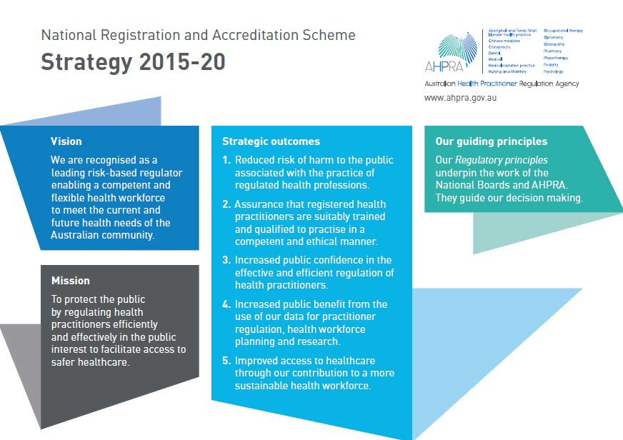

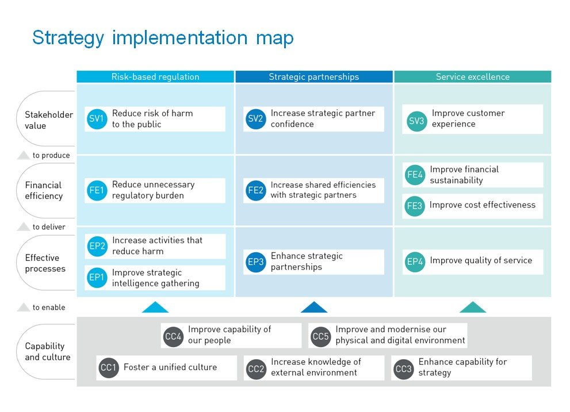

National Board Regulatory Plan 2017-18

Scheme strategic outcome | Initiative overview
Reduced risk of harm to the public associated with the practice of regulated health professions. | Notification trend project  Undertake an analysis of all notifications data relating to psychologists since the commencement of national regulation in 2010, and to identify key themes and risk factors to inform the development of tailored regulatory interventions.
Endorsement education campaign

Undertake a practitioner education campaign on endorsement and improve understanding about the Board’s requirements.
Assurance that registered health practitioners are suitably trained and qualified to practise in a competent and ethical manner. | Stage two of the education and training reform project - scoping the options for a future education and training pathway for psychology registration and endorsement.  This stage is focused on finalising the case for reform (particularly around analysis of workforce, training places/4+2 internships, health service impacts), developing the viable options to meet the stated objective/s to streamline the training pathway, assess the impacts of the options through a cost-benefit analysis and prepare a consultation paper to commence engagement with government, education (both students and universities), the profession and consumers.
Increased public confidence in the effective and efficient regulation of health practitioners | Psychology improvement project – stage three  To ensure effective delegated decision making to Regional Boards and AHPRA - consistent, fair and right touch regulation with effective oversight
Increased public benefit from the use of our data for practitioner regulation, health workforce planning and research | Workforce survey  Engage an expanded psychology-specific workforce survey to build a enhanced evidence base and to also support a number of the initiatives specifically the education and training review.
Exam item analysis

The aim of this initiative is to commission an item analysis of the National Psychology Examination (NPE) question bank to validate items against the required competencies of the NPE. The findings will be used to review and improve items/tests for future use and build an evidence base on the efficacy of the exam as a regulatory instrument.
Improved access to health care through | Enhancing the PsyBA supervisor training provider program

Scheme strategic outcome | Initiative overview
our contribution to a more sustainable health workforce. | Enhance and grow supervisor training providers through a new expression of interest process for new training providers, review program administration and undertake a communications campaign in preparation for renewal in 2018.
Prescribing of scheduled medicines for psychologists

Undertake a research project to explore an expanded scope of practice of psychologists to include prescribing of scheduled medicines.

Standards review

Standard, guideline and/or policy
Finalise Provisional standard and 4+2 internship program review
Finalise Area of Practice Endorsement registration standard and guideline review
Finalise the guideline for transitional programs
Exam curriculum including practice-based survey to validate the domains of the exam
Accreditation standards for psychology programs
Supervisors and supervisor training providers (guidelines) Supervisors and supervisor training providers revocation (policy)
PII arrangements (standard and guidelines)
Family Court Experts (policy)
5+1 internship program (guidelines)
Review of the Code of Ethics
Advertising (guidelines)
Mandatory notifications (guidelines) Social media (policy)

Schedule 3: Fees payable by health practitioners

PSYCHOLOGY BOARD OF AUSTRALIA
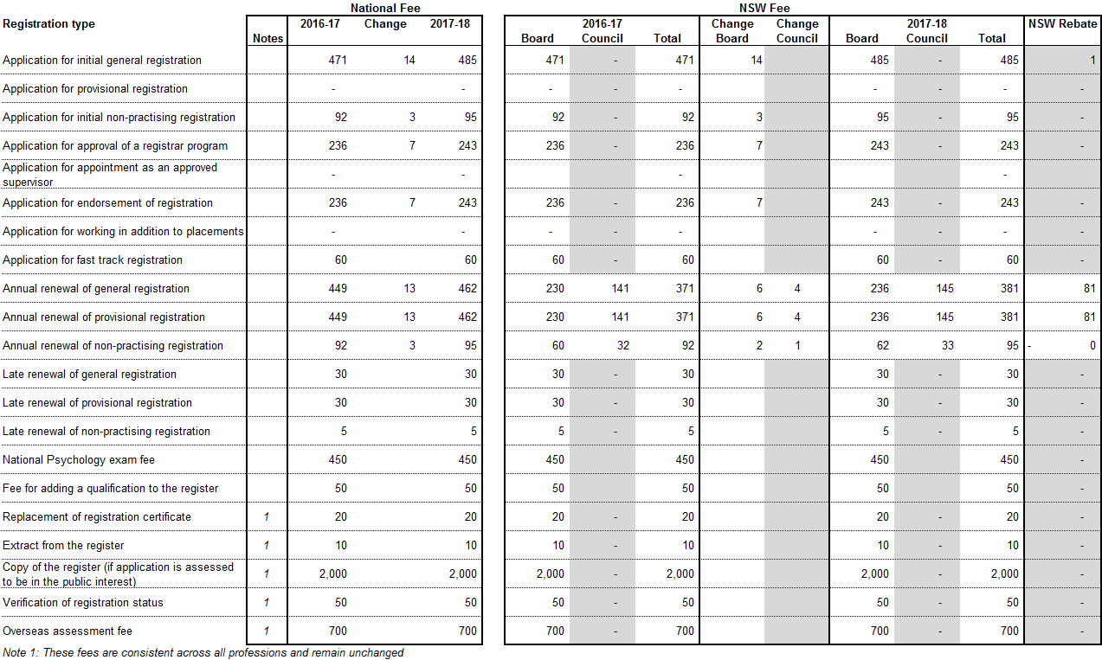

Health Profession Agreement 2016-20

Page 1 of 3

Schedule 4: Summary of National Board’s annual budget

PSYCHOLOGY BOARD OF AUSTRALIA

Income and expenditure budget and notes SUMMARY BUDGET 2017/18

Item
Income
Registration (see note 1) | $12,913,294
Application | $928,000
Interest | $223,000
Late Fees and Fast Track Fees | $56,700
Other | $493,300
Total Income | $14,614,294
Expenses
Board and committee (see note 2) | $1,552,599
Legal, tribunal costs and expert advice (see note 3) | $1,126,200
Accreditation (see note 4) | $961,300
Office of the Health Ombudsman (Queensland) | $73,800
Other direct expenditure (see note 5) | $504,100
Indirect expenditure (see note 6) | $11,053,450
Total Expenses | $15,271,449
Net Surplus (Deficit) | ($657,155)

The Board had equity of $2.561m at 1 July 2017 which is within the Board’s equity target range.

During 2017/18 the Board will use a component of this equity to further invest in the program of work and the upgrading of important support systems.

The Board will continue to work in partnership with AHPRA to ensure an appropriate and diligent financial strategy is in place beyond 2017/18.

Refer to the annual report for further information.

Health Profession Agreement 2016-20

Page 2 of 3

BUDGET NOTES

1. Registrant numbers | The budget for registration income is based on the following:  - Number of registrants invited to renew at next renewal period:35,026  • Lapse rate of renewals: ............................................................3.77%
2. Board and committee expenses | This covers the meeting costs of the National Board, as well as its state/territory/regional boards and committees, which have the delegated authority to make decisions about individual registered health practitioners.  Costs include sitting fees, travel and accommodation while attending meetings for the Board.
3. Legal, tribunal costs, and expert advice | These costs are incurred in the management of complaints against practitioners (notifications). The costs do not include the significant Board and committee costs, including sitting fees, related to notifications. These are included in ‘2’ above.  Also not included are the material staff costs in each state and territory office relating directly to notifications. These are included in “indirect expenditure” below.
4. Accreditation | Accreditation expenses include the costs of funding provided to the Australian Psychology Accreditation Council (APAC) for accreditation functions and related projects.
5. Other direct expenditure | Costs associated with the Board’s work on registration standards, policies and guidelines.  This includes the following activities:  - costs involved in consultation with the community and the profession  - engagement of consultants necessary to support the Board’s work  - publication of material to guide the profession, such as the Board’s newsletter, Connections  - Board member professional development, and  - policy development and projects.
6. Indirect expenditure | The proportion of AHPRA’s business as usual costs allocated to the Board as indirect costs is 6.74%. The percentage allocation for the Board in 2016/17 was 6.8%.  In addition, indirect costs include a one off cost of implementing a major information systems replacement program.  Indirect costs are shared by the National Boards based on an agreed formula. The percentage is based on an analysis of historical and financial data to estimate the proportion of costs required to regulate the profession. Costs include salaries, systems and communication, property and administration costs.  AHPRA supports the work of the National Boards and committees by employing all staff and providing systems and infrastructure to manage core regulatory (registration, notifications, compliance, accreditation and professional standards) and support services in eight state and territory offices.  The 2017/18 AHPRA business plan sets out AHPRA’s objectives for 2017/18 and how they will be achieved.

Schedule 5: Performance management framework
Volume and trend data reports

National Boards will receive quarterly AHPRA performance report and volume and trend reports in accordance with the Performance Reporting Framework. The Performance Reporting Framework will be reviewed in 2017/18.

