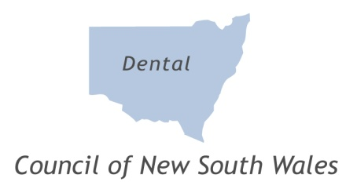

DENTAL COUNCIL OF NEW SOUTH WALES

SUBMISSION OF COMMENTS RE AHPRA
PRELIMINARY CONSULTATION ON COMMON CODES AND GUIDELINES

Dear Sir/Madam,

Thank you for the opportunity to provide direct feedback to AHPRA regarding the Preliminary Consultation on Common Codes and Guidelines. The Council would like to contribute the following comments to the proposed drafts on Social Media Policy, Guidelines for Mandatory Notifications and the Guidelines for Advertising; no further comments were offered concerning any of the other codes/guidelines. The Council responds as follows:

Draft Social Media Policy:

Increase the emphasis in the paragraph “Obligations in relation to social media” (page 42), that all microblogs from an individual practice or dental practitioner do come under the auspices of AHPRA’s Guidelines for advertising of regulated health services.

Draft Guidelines for Mandatory Notifications:

The section headed “Reasonable Belief” seems overworked and somewhat repetitive, particularly in paragraph 3 and 4. The Council is concerned this could lead to confusion and it would be preferable to streamline the paragraphs. It is acknowledge that this may have a forensic purpose, but it is not readily identified.

Draft Guidelines for Advertising:

Any photographs included in the advertisements (section 7.1) are of the practitioners’ own cases and not of another colleague or out of a textbook or dental journal.

To avoid confusing members of the public, where “Dr” is used in a title (section 8.2), the name of the profession i.e. Dentist rather than just BDS should also be stated.

Sue Hardman
Executive Officer
2 April 2013

