Responsible advertising in healthcare: Keeping people safe

June 2019

Advertising compliance and enforcement strategy for the National Scheme

The Australian Health Practitioner Regulation Agency (AHPRA) and National Boards regulate health practitioners in Australia through the National Registration and Accreditation Scheme (the National Scheme).

Our primary role is public protection and we aim to do this through a risk-based approach to regulation, taking action proportionate to the risks to public health and safety we have identified.

Our goal is to ensure advertising about regulated health services is done responsibly in order to keep the public safe from false or misleading claims and to assist them to make informed decisions about their healthcare.

This strategy explains:

* how our risk-based approach is applied to advertising compliance and enforcement
* how we encourage voluntary compliance and deal with non-compliant advertising, and
* how we plan to evaluate and refine this strategy.

1. **Introduction**
   1. **What we do**

The National Scheme regulates 14 health profession groups across Australia with more than 650,000 registered practitioners and 150,000 registered students.

There is a National Board for each health profession group that is part of the National Scheme, and the 14 National Boards work in partnership with AHPRA.

**This infographic shows the objectives of the National Scheme and actions that support them.**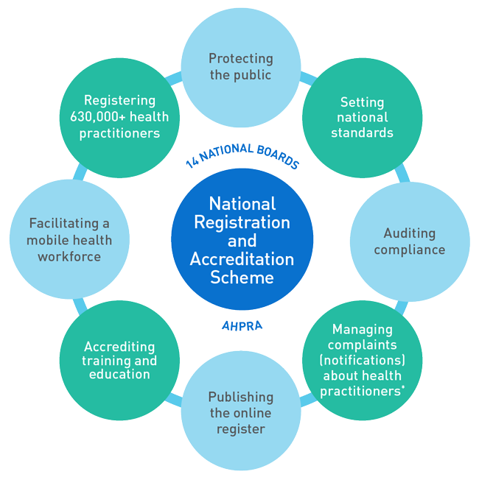

*Nationally, except in NSW and QLD where this is managed by the Health Professional Councils Authority and the 14 health professional Councils, and the Office of the Health Ombudsman, respectively.

The professions regulated are:

* Aboriginal and Torres Strait Islander health practice
* Chinese medicine practice
* chiropractic
* dental
* medical
* medical radiation practice
* nursing and midwifery
* occupational therapy
* optometry
* osteopathy
* pharmacy
* physiotherapy
* podiatry, and
* psychology.

Paramedicine is scheduled to join the National Scheme as a regulated profession from 2018 subject to passage of legislation to achieve this and to establish the 15th National Board.

Our work is governed by the Health Practitioner Regulation National Law, as in force in each state and territory (the National Law). Our responsibilities include registering practitioners and students, setting standards, and dealing with complaints.

*Advertising and the National Law*

Section 133 of the National Law makes it a criminal offence for any person (including registered health practitioners) to advertise a regulated health service or a business that provides a regulated health service, in a way that:

* is false, misleading or deceptive or is likely to be misleading or deceptive; or
* offers a gift, discount or other inducement to attract a person to use the service or the business, unless the advertisement also states the terms and conditions of the offer; or

* uses testimonials or purported testimonials about the service or business; or
* creates an unreasonable expectation of beneficial treatment; or
* directly or indirectly encourages the indiscriminate or unnecessary use of regulated health services.

The definition of a regulated health service is very broad and applies to public and private services. It is not constrained to direct clinical services.

Currently the maximum penalty for each advertising offence is $5,000 for an individual and $10,000 for a body corporate. These relatively low penalties are related to the protective nature of the National Scheme legislation and while acting as a general deterrent, the maximum penalty available for a conviction may not always seem proportionate to the offence, particularly in the most serious cases of false advertising.

However, if a registered health practitioner breaches the advertising offence provision of the National Law there are other enforcement approaches available. A breach of the advertising offence provision by a registered practitioner is also a breach of the Board’s advertising guideline and code of conduct, so the practitioner’s conduct is grounds for disciplinary action in relation to their registration. This is a core aspect of our enforcement approach.

Our regulatory work on advertising compliance includes acting on complaints, educating practitioners so they are aware of what is and what is not acceptable and taking action against unlawful, misleading or harmful advertising in the best interests of consumers of regulated health services. We also engage regularly with other regulators who are responsible for protecting consumers such as the Therapeutic Goods Administration (TGA) and Australian Competition and Consumer Commission (ACCC).

All National Boards have published *Guidelines for advertising of regulated health services* that explain the legal obligations of advertisers under the National Law. These apply to any person or business advertising a regulated health service.

We are continuing to publish additional information on the [AHPRA website](http://www.ahpra.gov.au/Publications/Advertising-resources.aspx) to help practitioners understand advertising and the National Law, and what their obligations are when it comes to responsible advertising when they advertise their services to the public.

* 1. **Compliance and enforcement strategy**

Our goal is to ensure advertising about regulated health services is done responsibly in order to keep the public safe from false or misleading claims.

This goal includes having advertising of regulated health services compliant with the National Law, so that the public has access to clear and correct information to help them make informed choices about their healthcare.

This strategy sets out how we aim to achieve advertising compliance, including how we will use the range of regulatory tools we have available. Publishing this strategy makes it clear to everyone reading this document what our approach is and what they can expect from us.

Our approach is evolving. We have included ongoing evaluation as a core part of our strategy, and we will continue to look for ways to refine and improve our approach.

* 1. **Principles**

Our [regulatory principles](https://www.ahpra.gov.au/About-AHPRA/Regulatory-principles.aspx) underpin all our work regulating Australia’s health practitioners, in the public interest. These principles shape our thinking about regulatory decision-making and encourage a responsive, risk-based approach to regulation.

Informed by our regulatory principles, the key principles that support our strategy are:

* **Risk-based:** We focus our resources on the highest risk matters and those with most potential benefit for the public. We will take different types of compliance and enforcement actions depending on the risk posed.
* **Targeted:** We recognisethere is no one size fits all approach. Our compliance and enforcement actions will be focused and fit for purpose, and depend on the type of behaviour identified. We take an evidence-based approach, including looking to research and other regulators for examples of best practice regulation and behaviour change approaches, with ongoing evaluation as a core part of our strategy.
* **Proportionate –** We take the minimum compliance and enforcement action appropriate to manage the risk posed, to protect the public.
* **Transparent –** We set clear benchmarks for advertising of regulated health services and provide authoritative guidance on what advertisers need to do to comply. We are clear about our planned approach to advertising compliance, and how we enforce compliance when appropriate. Our processes for decision-making and dealing with complaints support consistent enforcement outcomes and provide clarity for the public and advertisers about what is and is not acceptable in advertising. We are committed to reporting on action taken including through publishing case studies and enforcement outcomes.
* **Engaged –** Collaboration is central to our strategy.We work with the public to understand and be responsive to their expectations. We work with professional associations and health practitioners to support better advertising practices. We explore varied opportunities for learning and joint work with government, other regulators and stakeholders.
  1. **Using a risk-based approach**

We are a risk-based regulator. Applying a risk-based approach to advertising compliance and enforcement means that we take different actions depending on the level of risk identified and what action is likely to have the most impact in the circumstances.

We will focus our resources on the highest risk matters and those with most benefit to the public, recognising that we have finite resources.

Our risk-based approach is also about being responsive. Our strategy is flexible so we can respond to new or different types of risks, new or emerging ways to advertise, and evolving public expectations.

1. **Compliance and enforcement strategies**
   1. **Overview of compliance and enforcement model**

Effective compliance and enforcement strategies help create the environment necessary to support voluntary compliance and build community confidence in regulation. Such strategies promote evidence-based, well thought out and integrated approaches to achieve improved compliance behaviour.

In developing this strategy we considered our work to develop guidelines and other explanatory information about advertising rules and our data and experience related to receiving complaints about advertising.

We also reviewed the approaches of other regulators and have drawn on feedback from stakeholders. Our ongoing work with consumers to gain a better understanding of their experience of healthcare advertising is important, and will help us design interventions that support good outcomes for consumers.

There are many factors that influence whether registered health practitioners and other advertisers comply with the advertising provisions for regulated health services under the National Law. These include their professional experience, knowledge of the requirements, how effectively we communicate with them about their responsibilities, and professional norms, practice and expectations within the professions. There are also other general factors, including social and financial drivers.

In developing our approach we have considered all these factors that influence compliance behaviour, and have made judgements about advertiser attitudes to compliance. This helps us identify the most appropriate and targeted compliance and enforcement strategies to target different groups of advertisers.

Regulatory research has developed a compliance pyramid which is a well-established model for thinking about compliance attitudes and developing targeted strategies[1]. A key element of this model is acknowledging that most people are willing or try to do the right thing.

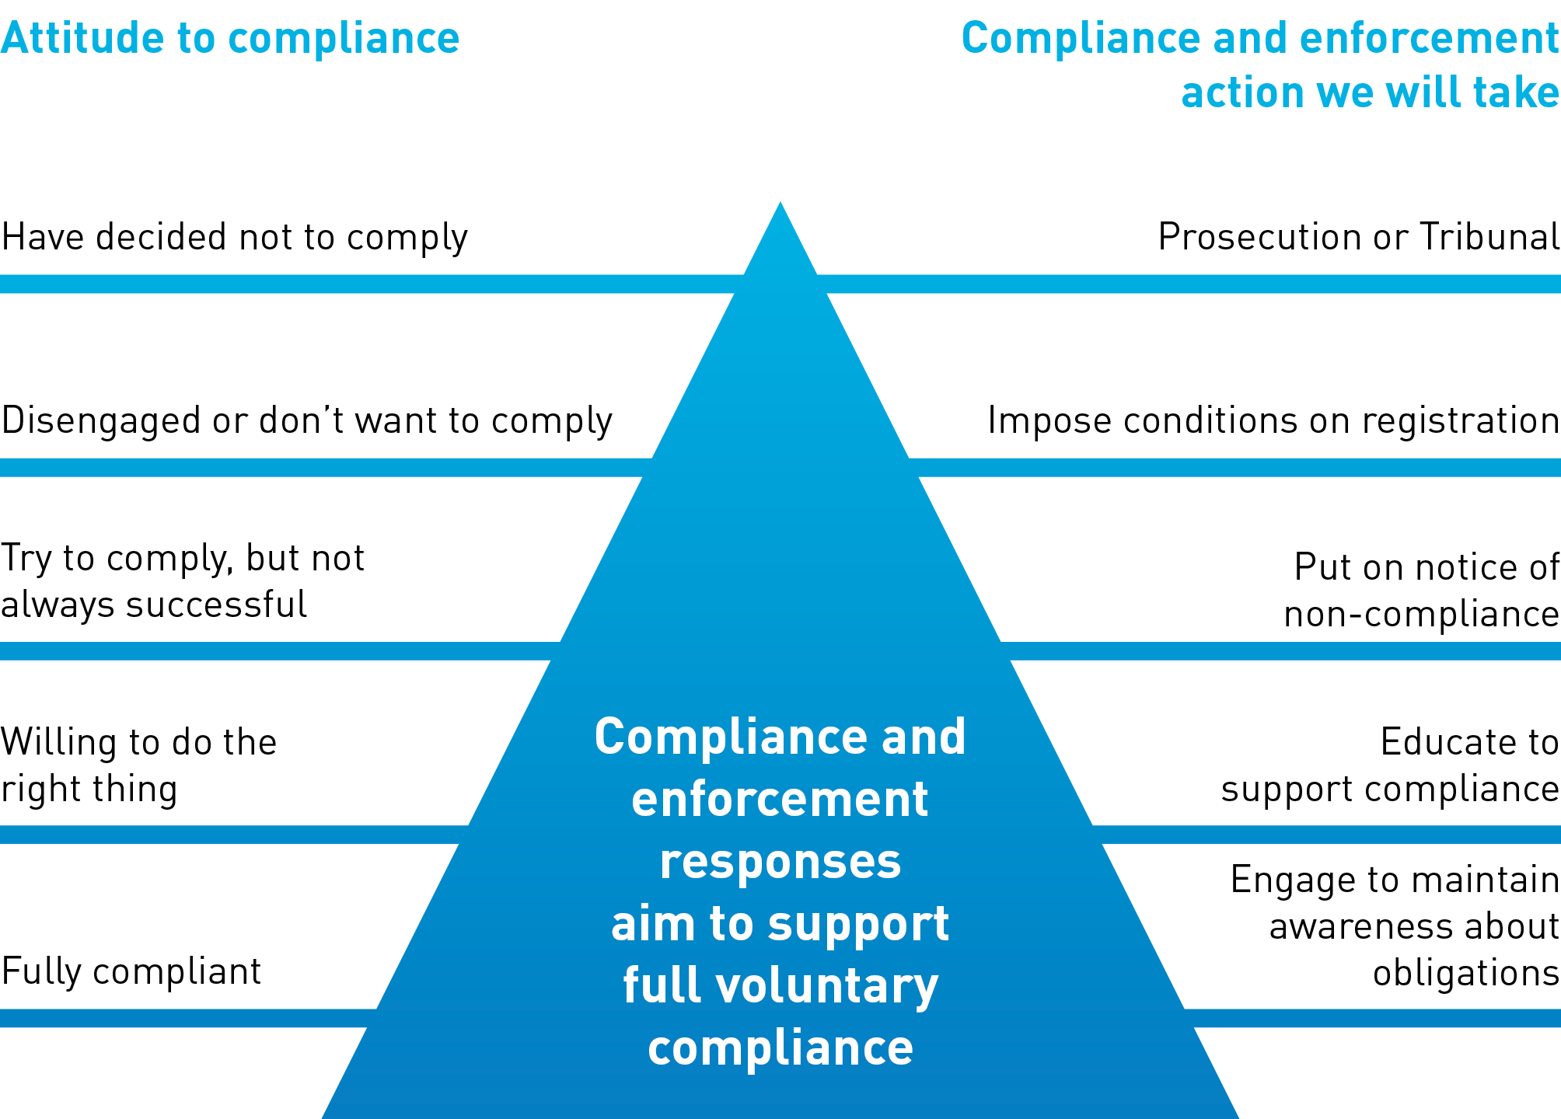

**The compliance pyramid**

We know that most practitioners want to comply with their professional obligations, and most people (including advertisers who are not registered practitioners) want to comply with the law. The main focus of our strategy is to make compliance easier for those who are willing to do the right thing. We recognise some people need more help to comply, and we will target activities to help this group achieve compliance.

We also recognise that there are a small number of people, both practitioners and other advertisers, who will need a bigger push to comply. This is where we target our enforcement action.

* 1. **Risk assessment framework**

All complaints that raise concerns about alleged criminal offences under the National Law are risk assessed. The issues considered when risk assessing includes the offence type and risk (such as allegations of potential or actual harm).

Types of matters we have identified as high risk (critical or major) include advertising practices that:

* raise concerns of actual harm to consumers
* make misleading claims about curing serious illnesses, such as cancer
* are targeted at patient groups that may be particularly vulnerable, such as advertising that is directed at consumers with serious illnesses or parents of children with certain childhood conditions that are not easily treated
* are widespread in a profession, and have potential to have significant adverse impacts on health care choices, and/or
* may also involve allegations of a person holding themselves out to be a registered health practitioner or unlawfully using a protected title.

We will periodically review and update this list as needed.

* 1. **Education and engagement**

Education and engagement are regulatory tools that have been shown to be key parts of an effective strategy in achieving behaviour change.

We will focus resources on these activities as we think these are the best way to reach the majority of people who want to advertise responsibly and to encourage higher performance.

Activities we will carry out to support compliance include:

* working more with consumers to understand their experiences of healthcare advertising and using these insights to develop interventions to support better outcomes for consumers
* developing further guidance for practitioners and other advertisers about advertising rules, consumer experience of advertising and tips for how to advertise responsibly
* comprehensive educational campaigns for advertisers (for example, about common mistakes made in advertising)
* developing specific education tools to respond to identified areas of concern
* engaging with advertisers and other stakeholders through webinars, social media, forums and other activities
* letting advertisers and the public know when we take action for non-compliant advertising, to make it clearer what is ok and what is not acceptable when advertising
* making it clear to advertisers when there are specific types of claims and areas we are concerned about (for example, specific claims which are misleading and not backed up by acceptable evidence)
* writing to practitioners and other advertisers if they are identified to be at risk of non-compliance, and
* partnerships with consumer groups, professional associations and other regulators on projects that support the strategy
  1. **Enforcement**

We will respond to all complaints about advertising and use a range of regulatory tools to address non-compliant advertising.

Compliance and enforcement action will escalate depending on the ongoing assessment of risk and the response of the advertiser.

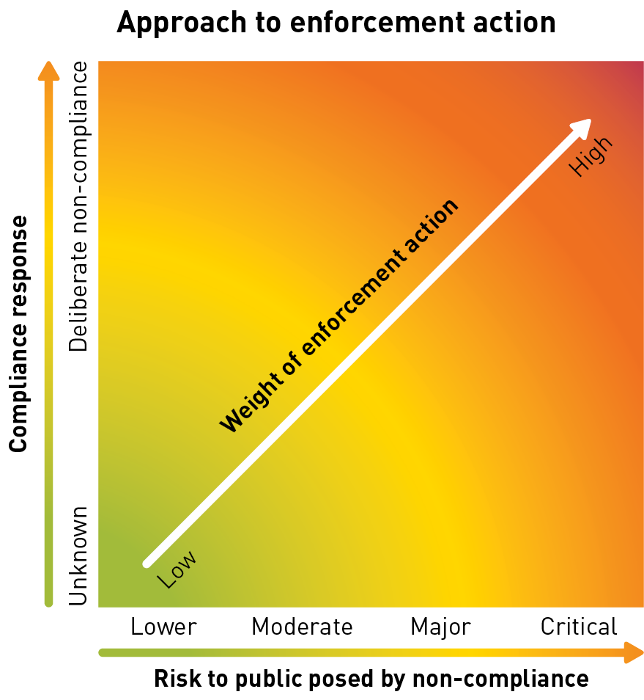

Enforcement tools available under the National Law include the power to:

* investigate a practitioner’s conduct
* impose conditions on the practitioner’s registration restricting their ability to advertise their services
* take disciplinary action in a panel or tribunal, and/or
  + prosecute an advertiser of a regulated health service (which may be a registered health practitioner, another person or a business).

Certain high-risk matters will be identified as suitable for prosecution or disciplinary action from the outset.

For alleged advertising breaches assessed as lower risk, we will write to advertisers to put them on notice that their advertising is non-compliant and provide resources to help them to comply with the National Law.

We have refined our communication to be more concise and targeted and are progressively developing further materials to help advertisers to comply, including educational resources and examples of acceptable and unacceptable advertising.

We will provide a timeframe for the non-compliant advertising to be amended, and will advise how compliance will be checked. We expect that many advertisers are keen to change their advertising once they are made aware of non-compliance and the range of possible consequences.

Following the initial correspondence to advertisers, compliance will be checked by targeted and random audits. Whether the advertising is part of a targeted or random audit will depend on the initial risk assessment of their advertising. Where continuing non-compliance is identified, the practitioner will receive a show cause letter proposing to impose conditions on their registration restricting the practitioner’s ability to advertise their services, and providing a further timeframe to amend their advertising.

If the practitioner’s advertising is not rectified, the conditions will be imposed and before the conditions are removed the practitioner will need to demonstrate their understanding of the advertising requirements. Enforcement action will escalate depending on the ongoing assessment of risk and the response of the advertiser. Continued non-compliance after the imposition of conditions may result in referral to a tribunal.

In future, we will publish summaries of compliance and enforcement action taken, and may identify specific areas of focus for enforcement action (for example, claims directed at certain patient groups or about certain health conditions).

1. **Review and evaluation**
   1. **Developing an evaluation framework**

Our strategy involves a mix of approaches, some of which are tried and tested, and some that we are piloting. We will use an evaluation framework to check whether what we are doing is improving advertising compliance, and to make sure our strategy remains contemporary and responsive.

We will report on the achievements of the strategy annually, and will also look at other ways to report on our progress, including in online news items and newsletters for practitioners.

* 1. **Review**

The initial review period for this strategy is 12 months.

Supporting documentation will be reviewed and updated as the strategy is implemented, including piloting new approaches and implementing the evaluation framework.

**Acknowledgements**

This strategy was developed by the National Boards and AHPRA.

**Copyright**

* Australian Health Practitioner Regulation Agency 2017

This publication may be photocopied, transmitted and distributed for educational or research purposes. Visit our website at [www.ahpra.gov.au/Publications/Advertising-resources/Legislation-guidelines.aspx](http://www.ahpra.gov.au/Publications/Advertising-resources/Legislation-guidelines.aspx) for PDF and Word versions of this document.

**Published**

Australian Health Practitioner Regulation Agency, Melbourne, April 2017

**Contact us**

**Phone**

1300 419 495 (within Australia)

+61 3 9275 9009 (outside Australia)

Monday to Friday 9am-5pm (Australian Eastern Standard Time)

**Email**

Via the [online enquiry form](https://www.ahpra.gov.au/About-AHPRA/Contact-Us/Make-an-Enquiry.aspx)

**Mail**

Publications Manager

AHPRA National Office

GPO Box 9958

Melbourne VIC 3000

**Web**

[www.ahpra.gov.au](http://www.ahpra.gov.au)

**Find us**

[Facebook](https://www.facebook.com/ahpra.gov.au/) [Twitter](https://twitter.com/AHPRA) [LinkedIn](https://www.linkedin.com/company/australian-health-practitioner-regulation-agency)

|  |  |  |
| --- | --- | --- |
| [Facebook icon.](https://www.facebook.com/ahpra.gov.au/) | [Twitter icon.](https://twitter.com/AHPRA) | [Linked in icon.](https://www.linkedin.com/organization/648146/admin/updates) |

1. Ayres I, Braithwaite J. Responsive regulation: transcending the deregulation debate. New York: Oxford University Press, 1992.