Physiotherapy registrant data: June 2015
Published August 2015

Introduction
The role of the Physiotherapy Board of Australia (the Board) include:
- registering physiotherapists and students
- developing standards, codes and guidelines for the physiotherapy profession
- handling notifications, complaints, investigations and disciplinary hearings
- overseeing the assessment of overseas trained physiotherapists who wish to practise in Australia, and
approving accreditation standards and accredited courses of study.
The Board’s functions are supported by the Australian Health Practitioner Regulation Agency (AHPRA). For information about legislation governing our operations see About AHPRA at http://www.ahpra.gov.au/About-AHPRA/What-We-Do/Legislation.aspx.
The Board has analysed its registration data and produced a number of statistical breakdowns about registrants to share with the profession and community. The Board shares these breakdowns regularly.
For more information on physiotherapy registration, please see the Board’s website http://www.physiotherapyboard.gov.au/Registration.aspx

Contents
Physiotherapy practitioners – registration type and sub type by state or territory 3
Physiotherapy practitioners – percentage by principal place of practice 3
Physiotherapy practitioners – endorsements by state or territory 4
Physiotherapy practitioners – registration type and sub type by age group 4
Physiotherapy practitioners – by age group 5
Physiotherapy practitioners – registration type and sub type by gender 6
Physiotherapy practitioners – percentage by gender 6

Physiotherapy practitioners – registration type and sub type by state or territory
Physiotherapy practitioners |  | Principal place of practice
Registration type | Registration sub type | ACT | NSW | NT | QLD | SA | TAS | VIC | WA | No PPP | Total
General |  | 501 | 7,645 | 167 | 4,951 | 2,169 | 425 | 6,426 | 3,264 | 894 | 26,442
Limited | Postgraduate training or supervised practice | 1 | 41 |  | 42 | 26 | 7 | 114 | 18 | 7 | 256
 | Public interest
 | Teaching or research |  | 10 |  | 7 |  |  | 3 |  |  | 20
Non-practising |  | 9 | 247 | 1 | 97 | 39 | 7 | 201 | 62 | 162 | 825
Total |  | 511 | 7,943 | 168 | 5,097 | 2,234 | 439 | 6,744 | 3,344 | 1,063 | 27,543
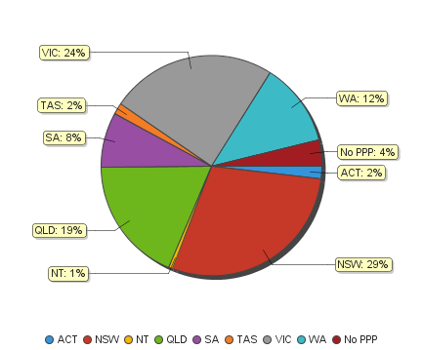
Physiotherapy practitioners – percentage by principal place of practice

Physiotherapy practitioners – endorsements by state or territory
Physiotherapy practitioners | Principal place of practice
Endorsement | ACT | NSW | NT | QLD | SA | TAS | VIC | WA | No PPP | Total
Acupuncture |  |  |  |  |  |  | 8 |  |  | 8

Physiotherapy practitioners – registration type and sub type by age group
Physiotherapy practitioners |  | Registration type/ Sub type
Age group | General |  | Limited |  |  |  | Non-practising
 |  |  | Postgraduate training or supervised practice | Public interest | Teaching or research |  |  | Total
U - 25 | 2,353 |  | 7 |  |  | 5 |  | 2,365
25 - 29 | 5,637 |  | 107 |  | 1 | 106 |  | 5,851
30 - 34 | 4,468 |  | 89 |  | 4 | 115 |  | 4,676
35 - 39 | 3,402 |  | 32 |  | 3 | 136 |  | 3,573
40 - 44 | 2,779 |  | 11 |  | 4 | 116 |  | 2,910
45 - 49 | 2,277 |  | 9 |  | 6 | 83 |  | 2,375
50 - 54 | 2,023 |  | 1 |  | 1 | 61 |  | 2,086
55 - 59 | 1,912 |  |  |  |  | 81 |  | 1,993
60 - 64 | 957 |  |  |  | 1 | 50 |  | 1,008
65 - 69 | 431 |  |  |  |  | 28 |  | 459
70 - 74 | 147 |  |  |  |  | 26 |  | 173
75 - 79 | 42 |  |  |  |  | 11 |  | 53
80+ | 14 |  |  |  |  | 7 |  | 21
Total | 26,442 |  | 256 |  | 20 | 825 |  | 27,543
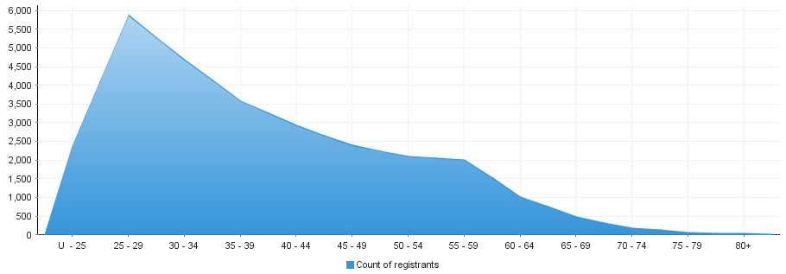
Physiotherapy practitioners – by age group
Age group | U - 25 | 25 – 29 | 30 - 34 | 35 - 39 | 40 - 44 | 45 - 49 | 50 - 54 | 55 - 59 | 60 - 64 | 65 - 69 | 70 - 74 | 75 - 79 | 80+
Count of registrants | 2,365 | 5,851 | 4,676 | 3,573 | 2,910 | 2,375 | 2,086 | 1,993 | 1,008 | 459 | 173 | 53 | 21

Physiotherapy practitioners – registration type and sub type by gender
Physiotherapy practitioners |  |  | Principal place of practice
Gender | Registration type | Registration sub type | ACT | NSW | NT | QLD | SA | TAS | VIC | WA | No PPP | Total
Female | General |  | 347 | 5,166 | 120 | 3,362 | 1,423 | 309 | 4,377 | 2,338 | 626 | 18,068
 | Limited | Postgraduate training or supervised practice | 1 | 33 |  | 27 | 18 | 4 | 79 | 12 | 5 | 179
 |  | Public interest
 |  | Teaching or research |  | 6 |  | 4 |  |  | 2 |  |  | 12
 | Non-practising |  | 8 | 212 | 1 | 70 | 33 | 5 | 159 | 49 | 115 | 652
Sub Total |  |  | 356 | 5,417 | 121 | 3,463 | 1,474 | 318 | 4,617 | 2,399 | 746 | 18,911
Male | General |  | 154 | 2,479 | 47 | 1,589 | 746 | 116 | 2,049 | 926 | 268 | 8,374
 | Limited | Postgraduate training or supervised practice |  | 8 |  | 15 | 8 | 3 | 35 | 6 | 2 | 77
 |  | Public interest
 |  | Teaching or research |  | 4 |  | 3 |  |  | 1 |  |  | 8
 | Non-practising |  | 1 | 35 |  | 27 | 6 | 2 | 42 | 13 | 47 | 173
Sub Total |  |  | 155 | 2,526 | 47 | 1,634 | 760 | 121 | 2,127 | 945 | 317 | 8,632
Total |  |  | 511 | 7,943 | 168 | 5,097 | 2,234 | 439 | 6,744 | 3,344 | 1,063 | 27,543

Physiotherapy practitioners – percentage by gender
Physiotherapy practitioners | Principal place of practice
Gender | ACT | NSW | NT | QLD | SA | TAS | VIC | WA | No PPP | Total
Female | 69.67% | 68.20% | 72.02% | 67.94% | 65.98% | 72.44% | 68.46% | 71.74% | 70.18% | 68.66%
Male | 30.33% | 31.80% | 27.98% | 32.06% | 34.02% | 27.56% | 31.54% | 28.26% | 29.82% | 31.34%

